Background Research on Hexapod Robot

Assignment 1 – MECH 464 Mechanism Design (Phase 1) – Yifan Ge

# Dynamic Autonomous Sprawled Hexapod – DASH (Simplest Hexapod) – University of California, Berkeley (Figure 1)

Key Features:

* One motor is sufficient to control the movement of robot
* Small in size which allows DASH to navigate into more confined environment
* Robust and light weight which allows DASH to survive after been dropped from high location or crushes
* Easy to assemble and build

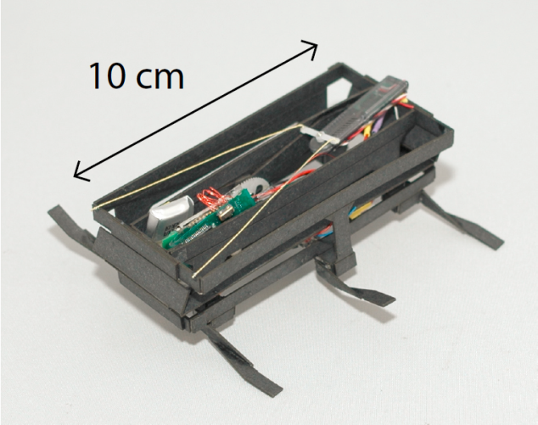

Figure 1 DASH

# X-RHex – University of Pennsylvania (Figure 2)

Key Features:

* Only one actuator is needed for each leg
* Simple mechanism design
* Be able to overcome high barriers
* Be able to choose high power density brushless DC motors, and drive them using COTS motor controllers
* Since the leg mounts are nearly centered on an overall thinner body, the robot can operate with greater ground clearance even when in an inverted state
* Center of mass has very small vertical movement when in motion
* High elevation from the ground

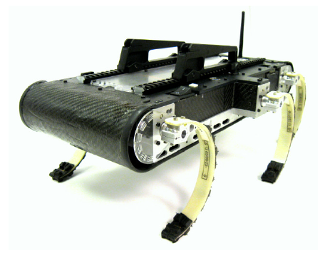

Figure 2 The X-RHex robot with handles attached

# Lynxmotion Hexapod Robot BH3-R (Figure 3)

Key Features:

* Each leg has 3 degrees of freedom which give the robot total of 18 degrees of freedom
* Flexible and capable of many different movement besides walking
* Easy to be customized for different purposes
* Steady and robust
* Has a larger platform on top of the robot for load

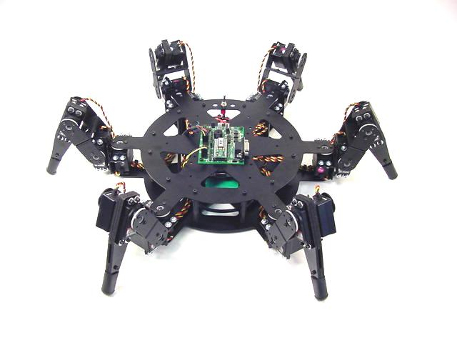

Figure 3 Lynxmotion Hexapod Robot BH3-R